**Applied Data Science Capstone Project**

**The Battle of Neighborhoods (Week 2)**

## Introduction/Business Problem

Clearly define a problem or an idea of your choice, where you would need to leverage the Foursquare location data to solve or execute. Remember that data science problems always target an audience and are meant to help a group of stakeholders solve a problem, so make sure that you explicitly describe your audience and why they would care about your problem.

The purpose of this project is to help people planning to open a new restaurant in Toronto to chose the right location by providing data about the income and population of each neighborhood as well as the competitors already present on the same regions.

Lots of people are migrating to various states of Canada and needed lots of research for good opening a Business like a restaurant. This project is for those people who are looking for better neighborhoods. For ease of accessing to a restaurant.

This project aims to create an analysis of features for people migrating to Scarborough to search the best neighborhood as a comparative analysis between neighborhoods.

It will help people who have businesses to get awareness of the area and neighborhood before moving to a new city, state, country, or place for their work and business.

So the Problem Which Tried to Solve:

The major purpose of this project is to suggest a better neighborhood in a new city for the person who is shifting there to open a new business. Sorted list of restaurants in terms of restaurant prices in an ascending or descending order.

# **Background**

In recent years Migrations to Canda are increased and most of the migrants are based at Toronto location. Due to increased housing prices in Toronto city area, people are preferring to locate little away from Toronto, but they find it difficult to locate good restaurants near their homes. In such a scenario, restaurants like Asian, Chinese or Italian cuisine restaurants would be a blessing for people and they won’t need to visit Toronto city central always.

# **Data**

Data Link: <https://en.wikipedia.org/wiki/List_of_postal_codes_of_Canada:_M>

For population: <https://en.wikipedia.org/wiki/Demographics_of_Toronto_neighbourhoods>

Will use Scarborough dataset which we scrapped from wikipedia on Week 3.

Dataset consisting of latitude and longitude, zip codes.

We will need data about different venues in different neighborhoods of that specific borough. To gain that information we will use "Foursquare" locational information. Foursquare is a location data provider with information about all manner of venues and events within an area of interest. Such information includes venue names, locations, menus, and even photos. As such, the foursquare location platform will be used as the sole data source since all the stated required information can be obtained through the API.

After finding the list of neighborhoods, we then connect to the Foursquare API to gather information about venues inside each neighborhood. For each neighborhood, we have chosen the radius to be 100 meters.

The data retrieved from Foursquare contained information of venues within a specified distance of the longitude and latitude of the postcodes. The information obtained per venue as follows:

1. Neighborhood

2. Neighborhood Latitude

3. Neighborhood Longitude

4. Venue

5. Name of the venue e.g. the name of a restaurant

6. Venue Latitude

7. Venue Longitude

8. Venue Category

*Shared IBM Notebook at*: <https://github.com/MohamedXMagdy01/AppliedDataScienceCapstoneCoursera/blob/master/Week5_Capstone%20Project(Week%202).ipynb>

# **3. Methodology**

In this project, I am going to make my effort into detecting the best area of Toronto to open an Asian restaurant as a business. I use population and number of restaurants in each neighborhood to know people of this neighborhood like what food to serve it to them. I am using Foursquare to find a good place to open a restaurant.

In the first step, I have collected the required data: Location data (Postcodes, Latitude, Longitude), Borough profile, venue data(like restaurants, cafes, and markets, and population Index.

In the second step, I am filtering the data frame so I will find the neighbors that have restaurants.

In the third step, I will use clustering technique to find differences among the venues and restaurants. I will use those clusters to decide where should I start to explore the neighborhood personally. I will present a map of all such locations as well.

# **4. Results**

* **Restaurants counts for all postal districts of Toronto**

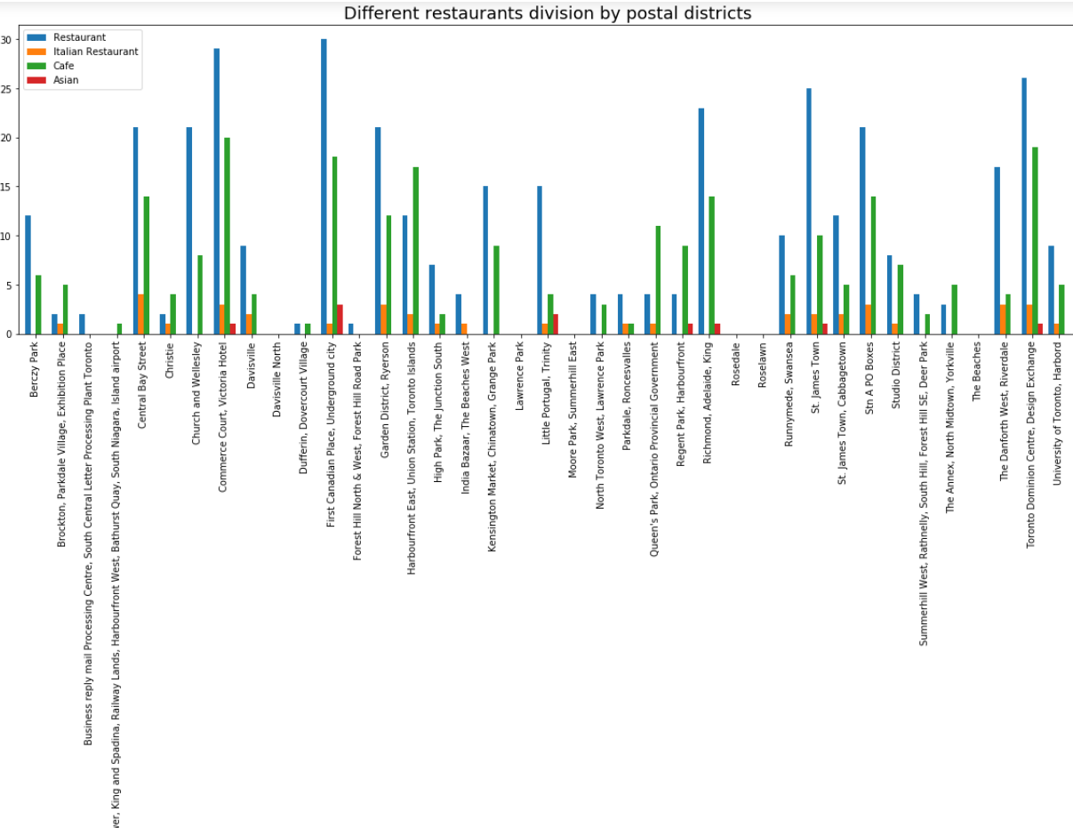

Asian Restaurants have less existence in Toronto City , Little portugal, Trinity, Richmond, Adelaide and king areas.

* **% of Restaurants for postal dist**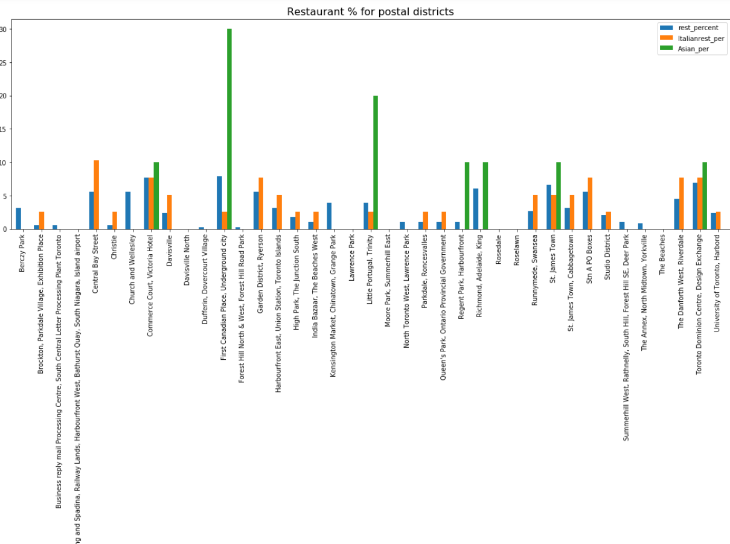

Both Dublin major area wise plots above indicates need of Asian restaurant

* **Map:**

**'Asian': 'red'**

**'Italian': 'green'**

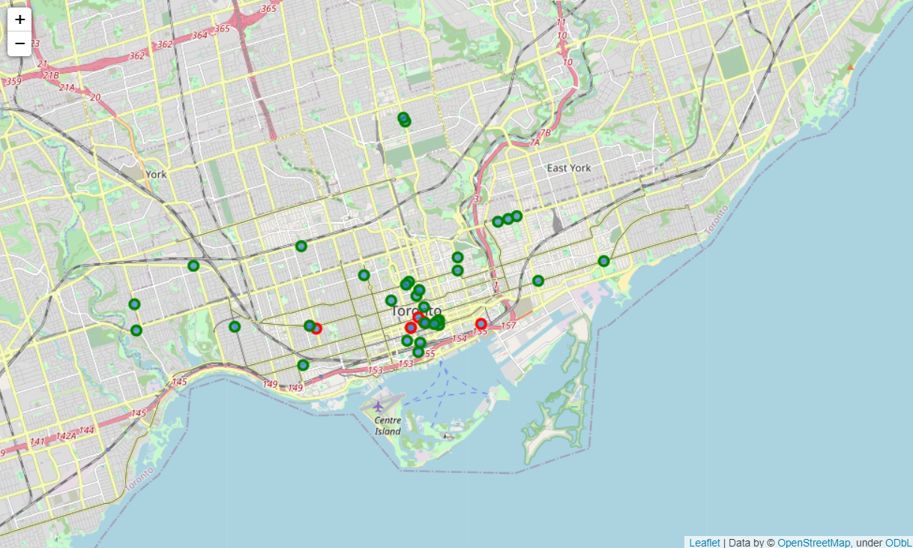

# **5. Analysis**

Overall Asian Restaurants have less existence in Toronto City. first canadian place, Underground city and Commerce court, Victoial hotel areas, region which has plenty of restaurants and cafe otherwise. Assuming Asian migrated peoples are settling in first canadian place, Underground city and Little portugal, Trinity postal districts majorly, hence Little portugal, Trinity can be a good potential area for Asian restaurant.

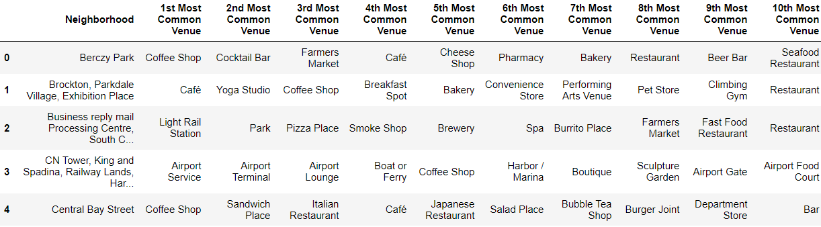

# **6. Conclusion**

Little portugal, Trinity, Richmond, Adelaide, king and Regent park would be potential regions to open a Asian Restaurant.

Assuming increasing population in Richmond, Adelaide, king and Regent park region, Asian restaurants would have good potential in these areas of toronto